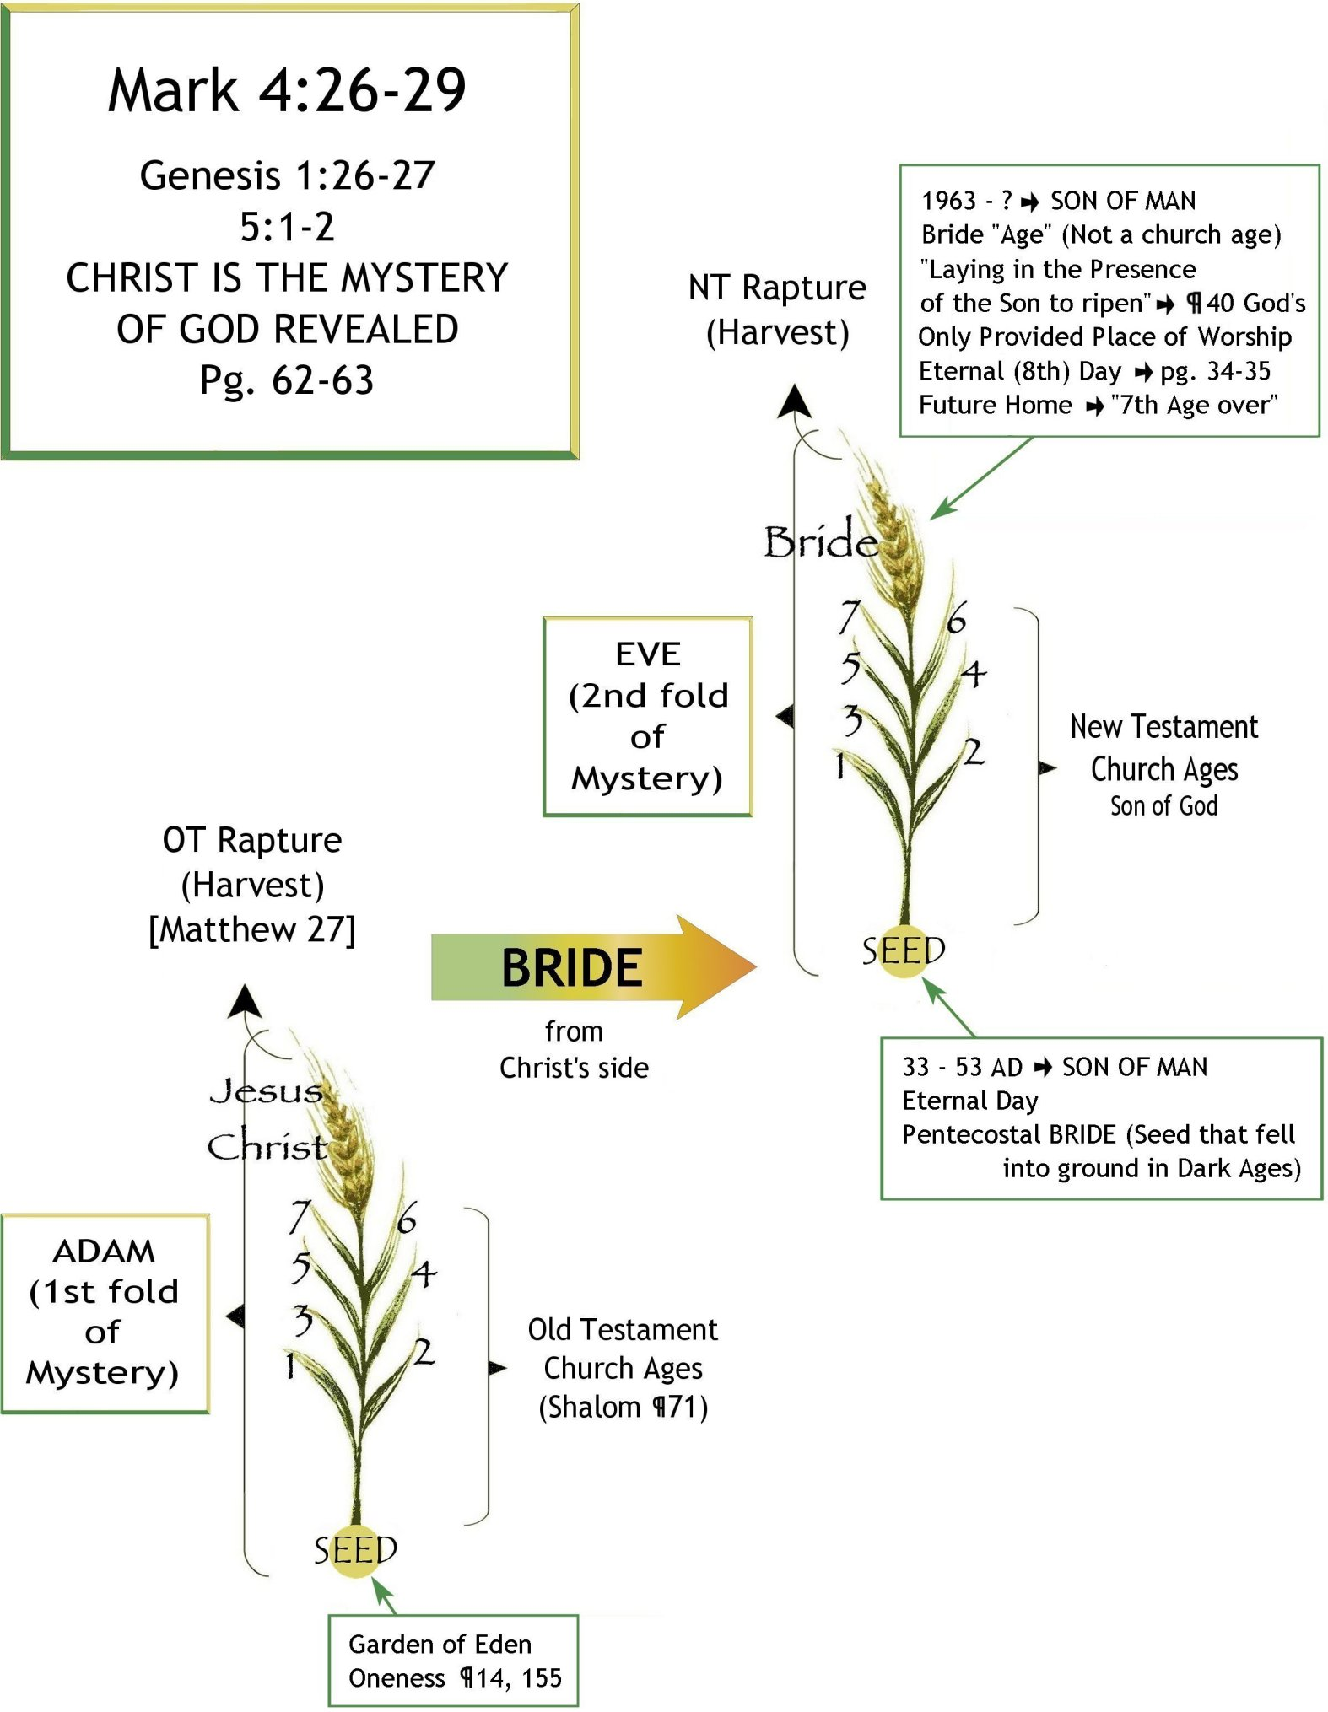
The Wheat Plant

SARDISEAN.CHURCH.AGE - CHURCH.AGE.BOOK CPT.7

282-1 To understand this subject even more clearly it will now be wise to approach it from the standpoint of the church through the ages. Up until now we have been thinking in terms of the removal of the names of individuals. Now we want to consider, not the individuals, but the groups represented in the church. To do so we will liken the church through the ages to the wheat plant. A grain of wheat is planted to the end that a single grain of wheat will reproduce and multiply itself through a certain process during a certain period of time. That single seed will die, but in dying, the life that was in it will come up into a plant which in turn will be the bearer or carrier of that life which is to come back to originality in a multiplied form. Jesus the great Royal Seed died. That matchless One Who is the life of the church stands in the midst of the church for all seven church ages giving His life to the church (the carrier or bearer) to the end that His very life will be reproduced in bodies like unto His in the resurrection. It is at the resurrection that the Royal Seed will see many royal seeds like unto Himself, and they will be even as He is, for says John, "we shall be like Him." This is what John the Baptist was referring to when He said that Jesus would gather the wheat into the garner. That was the resurrection where the redeemed who had been elected unto eternal life came in.

283-1 Now then, the record of this wheat plant whose end is to reproduce the original seed in multiplied form is THE BOOK OF LIFE. I repeat: the history or record of this wheat plant is the Book of Life of which a part of the Book of Life is the RECORD OF ETERNAL LIFE. (A section of the Book of Life). This is convincingly seen by examining the wheat plant. A bare seed is sown. Soon a blade is seen. But that is not the wheat yet. Then it grows into a stalk. This is not yet wheat. Life is there, but not the wheat. Then at the end of the stalk is a little spike that sends out a tassel. Still a wheat plant but no wheat yet. Then the plant is pollenized, and we see the chaff grow. This looks mighty like the wheat but it is not yet seed. Then forms the wheat in the husk. It is now back to what it was originally. Now the ripened wheat is harvested.

283-2 Jesus Christ died. He gave His life. That life was to come back upon the church and bring many sons like unto Himself unto glory in the resurrection. But as the wheat seed had to have a carrier to bring forth multiplied wheat seed, even so there had to be a church which would be the carrier of the life of Christ. As the blade, stalk, tassel, and husks were the carriers for the seed but NOT the seed itself, so the church corporate through the ages has been the carrier of the true SEED though not the Seed itself. That is why we can say that the Book of Life is the WHOLE WHEAT plant.

283-3 Let's go over that again. Here is that original seed that was planted. It produced a blade. That wasn't it. It produced a stalk. Not it either. Here come husks in which the wheat is to form. That isn't it. The tassel appears. THEN POLLEN FALLS ON THOSE PISTILS. PART OF THAT PLANT IS QUICKENED. SOMETHING OF THAT ORIGINAL SEED THAT CAME UP THROUGH THE REST OF THE PLANT TURNS INTO SEED. Why didn't the whole plant go into seed? Because it was created to that end. Just part of that plant can go back to being seed because just part of that WHEAT PLANT IS ETERNAL LIFE WHEAT.

Title Box

MARK 4:26-29
26 And he said, So is the kingdom of God, as if a man should cast seed into the ground;
27 And should sleep, and rise night and day, and the seed should spring and grow up, he knoweth not how.
28 For the earth bringeth forth fruit of herself; first the blade, then the ear, after that the full corn in the ear.
29 But when the fruit is brought forth, immediately he putteth in the sickle, because the harvest is come.

GENESIS 1:26-27
26 ¶ And God said, Let us make man in our image, after our likeness: and let them have dominion over the fish of the sea, and over the fowl of the air, and over the cattle, and over all the earth, and over every creeping thing that creepeth upon the earth.
27 So God created man in his [own] image, in the image of God created he him; male and female created he them.

GENESIS 5:1-2
1 ¶ This [is] the book of the generations of Adam. In the day that God created man, in the likeness of God made he him;
2 Male and female created he them; and blessed them, and called their name Adam, in the day when they were created.

CHRIST.IS.THE.MYSTERY_ JEFF.IN V-3 N-7 SUNDAY_ 63-0728
62-2 Now, remember, He is that Tree of Life contrary to the serpent's seed. You see? He's that Seed, the woman's Seed, the Tree of Life in the garden. And unless they put forth their hands and move this Tree, they'd eat that Tree and live forever. And He's the only Tree that can be taken that you can live forever. His Word is Life. And that be the Word then, the Word of God which Eve turned down in the garden of Eden, then here's Christ, the Word made manifest; and when He come on earth, He was the Tree of Life. Do you believe that? And Rome, what did they do? He had to be chopped down. And He was put on a tree of disgrace ("Cursed is he that hang on a tree"), become a curse for the human race. And now through that, He brings forth a Bride Tree, which will be the Tree of Life restored back to Him as Husband and Wife in the garden of Eden (Oh, glory to God.), by the same Word and the same God made manifested as Husband and Wife: the same Bride Tree back again (notice), making it known.
62-3 Now, my, there's just so much here, we could just keep on going. Notice, the Tree of Christ, the Body in the garden, making now--making His mystery known to this Bride Tree (watch) redeemed by Christ, the second Adam (You believe He was?), going back home to Eden with His fallen wife, redeemed back home again. That's Christ and the Church today--taking His Wife back. See the threefold mystery now? God manifested in Christ; Christ manifested in the Church; all together to bring back the original Adam and Eve again, man and woman, which are one, made out of the same Blood, and same Spirit, and everything else.
63-1 The Church is the Blood of Christ by the Spirit, because the Life is in the blood. That's the baptism of the Holy Ghost that baptizes us into His Body, that recognizes only His Body, His flesh, His Word. Denomination won't ever touch that; it's a revelation. She knows it. So did Eve know it; but she fell; but this one knows it and won't fall. She's ordained to. Hallelujah. She's ordained to not fall. She won't fail. She's predestinated to it. "Blessed is the man who God will not impute sin." You
ministers know what I'm speaking of when there's a couple dozen of you setting here. See? "Blessed is the man who God will not impute sin"--David.
63-2 Notice, redeeming back with Him, going home, back to Eternal Life in a human body, eating, drinking, living forever... Isaiah said, "They build houses and inhabit them, plant vineyards and eat the fruit." They'll not build, and another take it. The children won't take it, but they'll be there with their offsprings. He'll build it and stay there. Amen. He don't build and another eat; He builds and eats himself. Amen. What is it? His Bride going back with Him, redeemed back to the original Adam and Eve again. For it's...?... has left behind. They look back at the cross and see the death that's been paid. And now by faith we are resurrected with Him, setting in heavenly places right now, looking back to what redeemed us, waiting for the Husband to come to march on home with Him.
63-3 Threefold purpose of God manifested in Adam and Eve, and every prophet, and down through the ages, and He that is to come: He that was, He which is, and He which is to come, the whole manifestation, the revelation of the Word of God: Adam and Eve going back home again redeemed: God making Hisself known.

ADAM (1st Fold of Mystery)

ONENESS_ JEFF.IN V-10 N-2 SUNDAY_ 62-0211
14 Now, the first man and first woman in the garden of Eden was in perfect harmony with God, so much that God could come down at any time He desired and talk lip-to-ear with Adam and Eve. Now, that is perfect oneness: God and His creation, God speaking lip-to-ear with Adam and Eve. And they were so perfect in harmony with God till they were one with God. God and His family was one.

ONENESS_ JEFF.IN V-10 N-2 SUNDAY_ 62-0211
155 The debt of sin was paid. Jesus had to do this to send the--the--the Holy Ghost back upon to unite people again like it was in the garden of Eden. The debt was paid when Jesus died. That settled it. Amen, brother. If I could only get it to soak in. See?

SHALOM_ SIERRA.VISTA.AZ V-13 N-5 SUNDAY_ 64-0112
71 And that's the only way it can be done now, is when the Word is vindicated, God's written Word a-vindicated, then it shows Light. It's... A portion is lit, or put out for each age. We found it in the church ages; we find it in the Old--the Old Testament church ages. Each time that there come a time for a--a certain manifestation of the journey, there was a prophet came to the earth. And the Word came to the prophet, and he made that Word live. And when that Word was identified, it reflected God. And there was the--the age, there was the Light. And that's the way Light comes today.

MATTHEW 27:50-53
50 ¶ Jesus, when he had cried again with a loud voice, yielded up the ghost.
51 And, behold, the veil of the temple was rent in twain from the top to the bottom; and the earth did quake, and the rocks rent;
52 And the graves were opened; and many bodies of the saints which slept arose,
53 And came out of the graves after his resurrection, and went into the holy city, and appeared unto many.

EVE (2nd Fold of Mystery)

GOD'S.ONLY.PROVIDED.PLACE.OF.WORSHIP_ SHP.LA 65-1128M
40 I believe the church is begin to hear the message, and beginning to understand. But, friends, listen, we've got to lay in the Presence of the Son; we've got to be ripened. Our--our faith isn't ripe. Intellectually we're hearing the message that God has give us, and seeing the signs that He showed us, and proving it by the Bible as that; but, oh, how the church needs to lay in His Presence till it tenders up, you know, and gets sweet in the Spirit so that it can bathe down. Sometimes in speaking the message, you get harsh, have to break it in like that, because you've got to clinch a nail to make it hold. But when the church once gets it, the Elected is called out and separated then in the Presence of God, I know it'll be something like the people was there when it takes its rapture.

FUTURE.HOME_ JEFF.IN V-3 N-5 SUNDAY_ 64-0802
34-1 Notice, the eighth day Jesus raised for our justification, the eternal King with the eternal Kingdom, to be baptized into, to Eternal Life. Not seven days; had nothing to do with any of the days. It's speaking of another eternal coming; speaking of an eternal time--the world that I'm speaking of.
34-2 And notice, after fifty days, or seven sabbaths from there again, there come another holy convocation. What happened? The Holy Ghost fell on the day of Pentecost, on the seventh day--on the eighth day, rather, eighth day: fell on the eighth day was seven sabbaths later, exactly after His resurrection. See? So it'd be seven times that again; bring you right back around to the first day of the week again. Amen. Exactly. See?

FUTURE.HOME_ JEFF.IN V-3 N-5 SUNDAY_ 64-0802
34-5 See, eight cannot be counted with the week. See, it cannot be counted, eight days in a week; you can't do it (See?), because there's only seven days in a week. Count it any way you want to; Sunday's the first day of the week. See? You count seven, and you got to go back in and start over again. Count seven and come back and go over again. See, and we live through all these types in here, but when you hit the eighth you go on into eternity.
34-6 You don't come by laws, and rituals, and orders; you come by predestination. Amen. There's the genuine holy convocation. See, and we're ending the seventh church age--church age, the Pentecostal age. Do you see it? We're entering the holy convocation. We are entering into that real, genuine eternity, where the Church is called, not to some station, some denomination, but into eternity with their eternal King. See? We don't have it at all. There's no such a thing as days and things and times. You passed into Eternity, where you come from. You was there to begin with.

FUTURE.HOME_ JEFF.IN V-3 N-5 SUNDAY_ 64-0802
35-3 Now, in Ephesians 1:10 it's called (now, if you're putting it down)--Ephesians 1:10 is called, not a dispensation, not the seventh day; it's called the fullness of time. And when the fullness of time has come, that's when time has been fulfilled, when there is no more time, then you go into eternity. After the seventh church age is over (and it is); Luther's age is over; Methodist age is over; Pentecostal age is over, and now you go into what? Eternity. No more sevens; no more threes; no more of any... eternity, where there is no such time as numbers, and times, and things. Amen. Oh, my. You see it?

